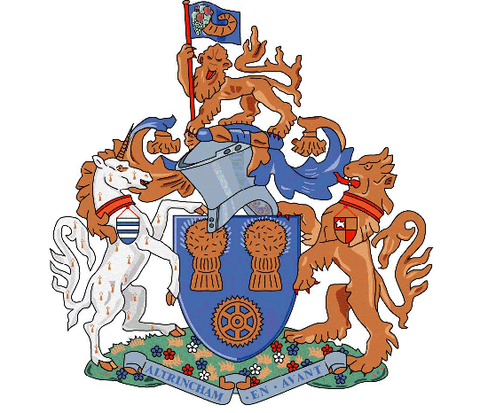

ALTRINCHAM FOOTBALL CLUB
COMMUNITY SPORTS LTD
The J. Davidson Stadium
Moss Lane, Altrincham,
Cheshire WA15 8AP
Telephone: 0161 928 1045
Fax: 0161 926 9934
Gift Aid declaration – for past, present & future donations
Altrincham Football Club Community Sports Co
Please treat as Gift Aid donations all qualifying gifts of money made
Today___ in the past 4 years ___ in the future___ (Please tick all you wish to apply.)
I confirm I have paid or will pay an amount of Income Tax and/or Capital Gains Tax for each tax year (6 April to 5 April) that is at least equal to the amount of tax that all the charities or Community Amateur Sports Clubs (CASCs) that I donate to will reclaim on my gifts for that tax year. I understand that other taxes such as VAT and Council Tax do not qualify. I understand the charity will reclaim 25p of tax on every £1 that I give on or after October 15th 2013.
Donor’s details
Title ---------- First name or initial(s) -------------------------------------------
Surname -----------------------------------------------------------------------------
Home Adddress ---------------------------------------------------------------------------------
-------------------------------------------------------------------------------------------------------
Postcode ----------------------------------
Date ------------------------------------- Signature --------------------------------

Please notify the charity or CASC if you:
- • Want to cancel this declaration
- • Change your name or home address
-  No longer pay sufficient tax on your income and/or capital gains. If you pay Income Tax at the higher or additional rate and want to receive the additional tax relief due to you, you must include all your Gift Aid donations on your Self-Assessment tax return or ask HM Revenue and Customs to adjust your tax code.

